**Student Questions**

Learn about the internals of a standard PC case by examining physical samples and selecting and labeling images found on-line. Gain deeper knowledge by researching and reporting on specific components.

PC Tower Case

Cooling Fan

1. Find one (or more) images that clearly show the internals of a PC Tower Case.   
   (i.e. Google images using keywords “PC Case Internals”)

Power supply

Motherboard

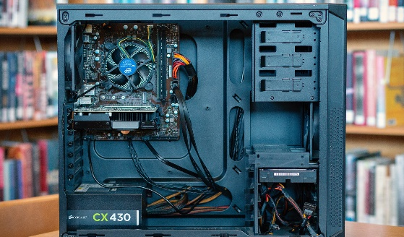

Audio Ports

Hard Disk Drive

Monitor Ports

USB Expansion Ports

Optical Disk Drive

1. Clearly label the following components (using arrows) on your image of the PC case internals:
   1. Motherboard

Ethernet Ports

* 1. Power Supply
  2. Hard Disk Drive
  3. Optical Disk Drive (e.g.DVD)
  4. USB Expansion Ports
  5. Monitor Port
  6. Audio Ports
  7. Ethernet Port
  8. Cooling Fan

1. Research more in-depth about “Hard Disk Drives”. Make notes on the following:
   1. What different versions are currently available (speed and capacity) The most two common versions are the Modern HDDs which are for desktop computers and the 2.5 inch which are for laptops.
   2. How the capacity of the component has changed since the 1980’s  
      In the 1980s there would only be about 10MB in a single hard disk drive. By 1999 the largest capacities would be 170MB and 340MB. By 2013 a hard disk drive with 6TB in it was released.

PC Motherboard

1. 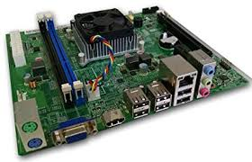Find one (or more) images that clearly show the layout of a PC Motherboard.

Ethernet Network Interface

Sound Processor

GPU

Disk Drive Interface

RAM Memory

Fan

1. Clearly label the following components (using arrows) on your image of the PC motherboard:
   1. CPU (and fan)
   2. RAM Memory
   3. Disk Drive Interface (IDE or SATA)
   4. GPU Graphics Processor (either on-board or Graphics Card)
   5. Sound Processor (either on-board or Sound Card)
   6. Wi-Fi / Ethernet Network Interface (either on-board or Graphics Card)

1. Research more in-depth about “CPU Processor Chip”. Make notes on the following:
2. What different versions are currently available (speed and capacity)
3. How the speed of the component has changed since the 1980’s  
   Since the 1980s the speed of a CPU Processor Chip has changed a lot.

Peripheral Devices

1. Find one (or more) images that clearly show the layout of the back of a typical PC tower case.   
   (i.e. Google images using keywords “Back Of PC Tower”)  
     
   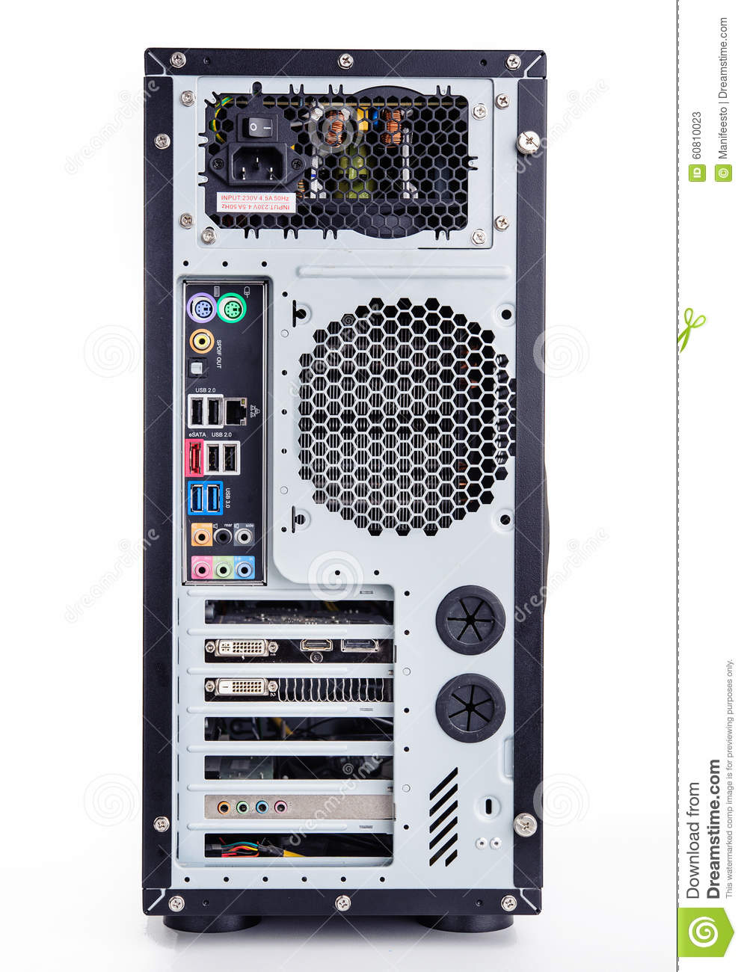

Ethernet Interface

Audio Inputs / Outputs

USB Ports

Keyboard Interface

Mouse Interface

Monitor Interface

Power cord and switch

1. Clearly label the following components (using arrows) on your image of the back of a typical PC tower case:
   1. Power cord and power switch
   2. Monitor Interface (VGA or DVI or HDMI)
   3. Mouse Interface (USB or PS/2)
   4. Keyboard Interface (USB or PS/2)
   5. USB Ports
   6. Audio Inputs / Outputs
   7. Ethernet Interface

1. Research more in-depth about “External Portable Storage”. Make notes on the following:
2. Floppy Disks

It is a flexible removable magnetic disk that is typically used in hard plastic for storing data

1. CD-ROM / DVD / Recordable CD/DVD

It is a compact disc which used as a read only optical memory device for a computer system

1. USB Memory Drives

It is a USB drive used to store memory on it through a computer or whatever device

1. Compact Flash Memory

It is a memory card that uses flash memory technology to store data on a small portable device.

1. Cloud Based Storage

**Presentation Outline**

Explore the development and features of a specific PC hardware component through deeper research and investigation. Work in partners to create a short presentation. Deliver the presentation to the class.

Each group will research a unique PC hardware component. Your specific topic will be assigned from the list provided below.

**Presentation Structure**

1. Explain what the PC component does and how it fits together with other components to make up a fully functioning PC.
2. Explain how the PC component works. Provide a diagram (image) showing the main parts of the component.
3. Research the current state of the art of the component in terms speed, capacity (size), and other related factors.
4. Research on-line suppliers that sell the PC Component. List the specifications for the available products and the cost (price).
5. Research how the PC component has changed and evolved since the early days of PCs in the 1980’s. Cover each of the following topics separately:
   1. Component Speed
   2. Component Size / Capacity
   3. Two other specifications specific to the PC component (ask Mr. Nestor)

**PC Component Topics**

|  |  |  |
| --- | --- | --- |
| **Topic** | **Partner 1** | **Partner 2** |
| CPU Microprocessor Chip |  |  |
| Motherboard Layout |  |  |
| Computer Graphics |  |  |
| Sound & Audio |  |  |
| Hard Disk Drives |  |  |
| Removable Disk Storage |  |  |
| Ethernet / Fiber Connectivity |  |  |
| Wifi / Bluetooth Connectivity |  |  |
| Mouse / Pointing Devices |  |  |
| Monitor & Display Technology |  |  |
| Printers & Output Technology |  |  |